**Langmuir Probe System Design, Operation, and Analysis**

**The Idea of Langmuir Probe Operation**

A Langmuir probe is the most commonly used diagnostic tool for plasma analysis to retrieve a measurement of the electron temperature and the ion number density. The probe consists of the probe tip, the shielded area, and the electrical contact point. It is then mounted inside of a sealed vacuum flange to allow it entry into the plasma vacuum system. The probe tip is an exposed piece of conducting material such as Tungsten which is the most common due to its high durability through exposure to high temperatures. The probe tip can be any shape or size but the most commonly used is a thin wire. The shielding is made of an insulating material that covers the remainder of the wire that would otherwise be exposed to the plasma. This is required to add extra length to the probe and allow it to be fed into larger chambers. The purpose of shielding the wire is that it is desired to have the probe tip, or collecting area, be relatively small (although this does depend on plasma conditions). The wire and the shielding are connected via a feedthrough flange to a metal contact outside of the plasma chamber. This metal contact is where outside hardware is attached to. If the probe is a shape other than a thin wire (planar square or spherical for example) then the probe tip is attached the wire within the shielding, leaving only the desired shape exposed.

The general idea of the Langmuir probe is to use the outside metal contact to connect a voltage source to. As the probe is biased positively or negatively with respect to the plasma, it starts to attract the free electrons or the positively ionized atoms of the plasma respectively. These particles are drawn to the probe to varying degrees depending on the magnitude and polarity of the biasing potential. At a high enough positive bias only electrons are drawn to the probe as the positive ions are repelled by the positive bias and conversely at a high enough negative bias, only the positive ions are drawn to the probe as the electrons are repelled. As the particles move towards the probe, they will eventually contact the probe and be collected. This collection results in a current flowing through the Langmuir probe (either into the plasma or being drawn from the plasma depending on polarity). In between these two voltages where the electrons or ions are completely repelled, a mixture of the two particles will be collected by the probe as some of the particles will have random velocities high enough to overcome the repelling force and contact the probe. Therefore, at all voltages except the extreme levels where total repulsion occurs, the total current is the summation of electron and ion current. This total current is what we measure to acquire the data required to analyze the plasma. To acquire the data, the current must be measured on the same connection as the supplied bias voltage. The current values at the extreme voltage values where the current is due only to electrons or ions are called the electron and ion saturation currents respectively. In order to extract the electron temperature and the ion density from these current values, it is required to record how the overall current changes with changing voltage. Therefore, a Langmuir probe is always operated with voltage sweeps from a large negative voltage to a large positive voltage. The plot of current versus voltage is called the IV-curve which is used to perform the analysis.

**DESIGN**

The design of the Langmuir probe measurement system began with developing circuitry to send a voltage waveform to the Langmuir probe and read back a current value on the same line. Preliminary testing of the system was conducted using a diode with one side tied to ground to mimic the operation of a Langmuir probe in plasma. A diode works to mimic the Langmuir probe due to the IV-curve characteristics that it creates. When a positive voltage is applied across the diode it lets current flow and a relatively large measureable current is obtainable. Then, at negative voltages, the diode turns off and allows little to no current to flow. This is similar to the Langmuir probe because at positive voltages, the electron current is collected and it is much larger than the ion current collected at negative voltages. Therefore the curves produced are qualitatively similar. The most important reason that a diode can be used as simulation is that it allows a single line to provide the bias voltage and to measure the return or sourced current on the same line in the same fashion as a Langmuir probe.

To create the voltage signal, a National Instruments (NI) Data Acquisition (DAQ) card was programmed to provide an analog output waveform of any desired shape or frequency. The analog output of this DAQ has voltage limits of +/- 10 V. The programming and operation of the DAQ is accessed using LABVIEW software. The normal operation of the Langmuir probe voltage sweep is to use either a triangular waveform or a sawtooth waveform. When using a triangular waveform there is potential to pick up slight hysteresis effects in the curve and end up with different current values for the same voltage setting. This may be of use as a diagnostic tool in certain applications but it is generally not a desired trait. Therefore, a sawtooth curve is normally chosen and is also chosen for this design. The next step is to develop the circuitry that will interface the DAQ voltage waveform to the Langmuir probe. To apply the voltage to the probe is a simple task: simply attach a wire to the probe contact. The challenging aspect comes in two forms. The single line connected to the Langmuir probe will have current running through it that not only needs to be measured by a separate channel on the DAQ but also needs to be routed so as to not run directly into the device potentially causing damage due to its magnitude. Therefore, the circuitry needs to protect the DAQ from direct return current by diverting the current to measurement circuitry that can then be read in by the DAQ on a separate channel.

This type of circuitry is provided by using an op-amp in a transimpedance amplifier configuration. Figure 1 shows a diagram of the configuration of this type of amplifier. This configuration solves both of the above mentioned problems. The voltage that is applied to the non-inverting terminal of the op-amp is transferred through to the inverting terminal as this terminal forms a virtual ground thus allowing it to mirror the input voltage. This means that the voltage signal will be properly applied to the Langmuir probe. The problem of protecting the voltage generating DAQ is accomplished because any current returning on the inverting line will travel up into the resistor RF and be contained within the top loop. Finally, with the return current travelling through the resistor RF, all that needs to be done to measure the current is to measure the voltage drop across the resistor and use the resistance value to convert this measurement to a current measurement. The only catch to this design is that the implemented op-amp has to be a high voltage high current op-amp that is capable of sourcing and sinking high currents which is not a characteristic of the common op-amp. Along with building the transimpedance amplifier system, circuitry is also needed to boost the voltage signal above the +/-10 V that the DAQ can provide. An amplification of ~10 times is sufficient to allow for proper measurement of the Langmuir probe I-V curves. This portion of the design is accomplished with a non-inverting amplifier implementation with voltage supply rails of +/-100V.

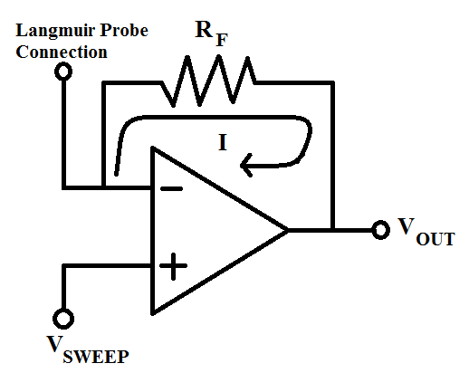

**Figure 1:** Circuit diagram of transimpedance operational amplifier configuration.

The system that has been described, with some additional components, was built by a former graduate student who worked in the same laboratory. Upon inspection of his design, it was concluded that the circuitry could be easily modified to disable the additional components of the system and isolate the above described circuitry of voltage amplification and current readout. The isolated circuitry can then be integrated to the DAQ and used to operate the Langmuir probe. The circuit diagram of his design is shown in figure 2. The VIN signal in the diagram is where the DAQ voltage signal will be connected to and the ‘Measured Current’ line will be connected to the DAQ Analog Input measurement terminal. With this modified system implemented, the design is complete and the Langmuir probe is operational.

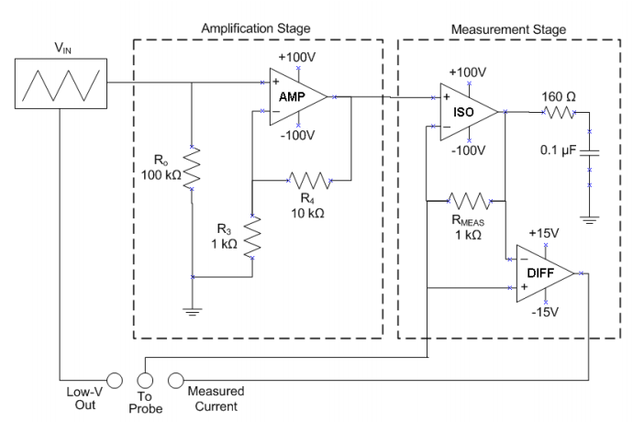

**Figure 2:** Circuit diagram of the voltage amplification system and the current measurement system. Image obtained from Desautels.

**Langmuir Probe Theory as Applied to Data Analysis**

**Ideal Current Voltage Curve and Definitions**

As mentioned previously, the general idea behind Langmuir probe operation is to measure the current that is created by applying a voltage to the probe allowing it to collect ions and/or electrons depending on the bias potential. When the current measurements are plotted versus the applied voltage, an I-V curve is created that is used to analyze the plasma properties. There are different sections of the I-V curve that have different functional dependencies and provide different information on the plasma. Figure 3 shows a plot of an idealized, or theoretical, I-V curve with labels showing important sections and points of the curve.

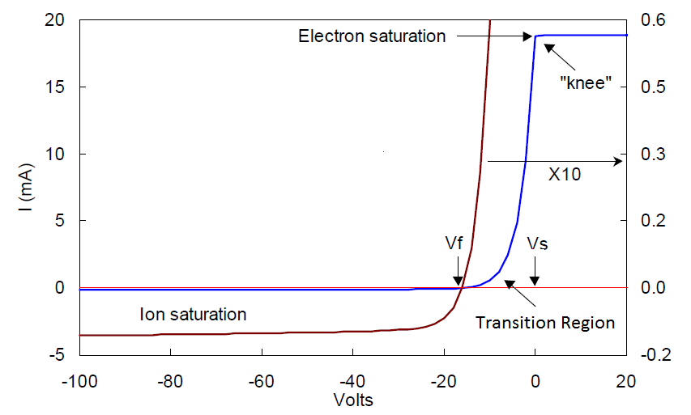

**Figure 3:** An idealized I-V curve. The red curve on the left is expanded 10X to show details of the ion saturation current section of the curve. Image adapted from Chen.

The curve is divided into three main regions: ion saturation, electron saturation, and transition region. In the ion saturation region, the probe is biased to a high enough negative potential that the probe repels all electrons and collects only ions. The current here will theoretically become a flat line as increasing the negative bias beyond this point will not increase the current as the probe is already collecting the maximum possible ions and zero electrons. This is because the ions have a fixed velocity and thus have a maximum rate at which they can contact the probe. Increasing the probe bias past the point where there is zero potential boundary to overcome will not increase the collection rate. Similar to the ion saturation region, but with opposite polarity, the electron saturation region is reached when a high enough positive bias is applied such that all ions are repelled by the probe and only electrons are collected. As with the ion saturation, the electron saturation current will theoretically flatten as increasing the bias voltage will not increase electron collection. There is however one other major difference between these two regions besides polarity. The electron saturation current is much higher than the ion saturation current (10-100 times higher). On first glance, this doesn’t seem quite right. Being that a plasma is considered to be quasi-neutral (roughly equal number ions and electrons) it would be expected that the ion and electron saturation currents should be equal as the probe should collect the same amount. The difference comes from the difference between the ion mass and the electron mass (Mion > me). Due to this difference in mass, the velocities of the two are also very different as the electron velocity is much greater than the ion velocity. This leads to more electrons being able to be collected by the probe than ions in the same amount of time. Since current is simply charge per second, this explains why the electron current is so much larger than the ion current.

The third main region of the curve is the transition region which is simply located between the two saturation regions. In this region, the ion current starts to become negligible and the electrons are only partially repelled by the negative bias. As the bias increases, the ion current decreases and the electron current increases. In a Maxwellian plasma, this part of the curve is exponential, i.e. the electron current increases exponentially. The final two points of interest on the plot are Vf and Vs which are the floating and plasma potential respectively. The floating potential is the point on the curve where the ion and electron currents are equal thus producing zero net current flow. The plasma potential is the voltage at which the plasma naturally sits at. This potential is reached because once the plasma is created the faster electrons start to contact the chamber walls and are absorbed at a higher rate than the ions due to their lower velocity. Therefore, the plasma starts to become electron depleted as a whole. This causes the plasma to become effectively positively charged which raises its potential. By raising the potential, the plasma starts to attract the electrons in and repulse the ions out to the walls eventually evening out the absorption rate and becoming quasi-neutral. However, after this has been achieved, the plasma still has an effective positive potential to maintain this balance. The plasma potential is effectively the ‘zero voltage reference’ for all applied voltages. If the applied voltage is greater than Vs then the probe attracts electrons and if less than Vs it attracts ions. This voltage typically occurs near to or at the knee of the curve.

**Experimental Curves**

As with many other experimental measurements, the I-V curves that are measured by a Langmuir probe in practice do not turn out to be as ‘clean cut’ as their theoretical counterparts. Figure 4 shows an experimentally measured I-V curve with the same labels as figure 3 for comparison. In comparing these two curves, the overall trends look similar with an exponential transition region in the middle and two distinct regions that deviate away from the exponential shape to distinguish the ion electron saturation regions. The biggest difference is the shape of the saturation regions and the ‘rounding off’ of the knee. The rounding off of the knee is due to a variety of factors such as collisions and the presence of magnetic fields [Chen]. The change in the ion saturation region is that the curve becomes sloped and does not reach a stable saturated value. This is because as the bias voltage is increased in magnitude (positive for electron and negative for ion) it changes a property of the Langmuir probe known as the plasma sheath. Simply put, the plasma sheath is a boundary between the physical area of the probe and the bulk of the plasma. Any ion or electron that enters the sheath is considered to be collected by the probe as it will contribute to the current. Therefore, the plasma sheath can be thought of as the effective collecting area of the probe. The size of the plasma sheath has a dependence on the bias voltage that is applied. The larger magnitude of voltage applied, the larger the sheath will become i.e. it expands. Therefore, once the I-V curve leaves the transition region and enters the saturation region the current continues to grow only due to the expansion of the sheath which leads to the sloped behaviour. The behaviour here is generally approximately linear but the relationship can become Ip vs V where p can be 2, 4/3, 5/3, etc. depending on the plasma properties (most notably density). Both saturation regions of the curve shown in figure 4 exhibit an approximately linear (p = 1) relationship.

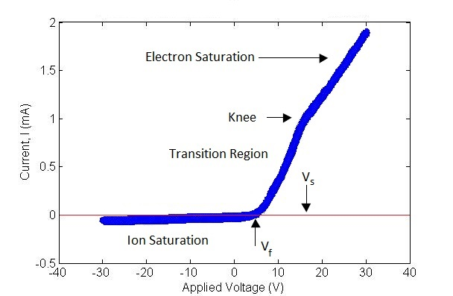

**Figure 4:** Experimentally measured Langmuir Probe I-V curve.

**Data Analysis**

In addition to the regions and points that have been discussed so far, the true power of the I-V curve lies in the analysis of the data where important plasma properties such as electron temperature and ion density can be extracted. The first and arguably easiest plasma property that can be retrieved from data analysis is the electron temperature. The exponential growth of the transition region is governed by the electron temperature. The equation for the current ($I_{e}$) in this region is given as:

$$I_{e}=I_{es}exp\left[\frac{e\left(V_{p}-V_{s}\right)}{k_{B}T_{e}}\right]$$

where $I_{es}$ is the electron saturation current, $e$ is the elementary charge, $V_{p}$ is the probe potential or the externally applied bias, $k_{B}$ is the Boltzmann constant and $T_{e}$ is the electron temperature in Kelvin. The factor $e/k_{B}T_{e}$ is equivalent to $1/T_{ev}$ where $T_{ev}$ is the electron temperature in electron volts. With this factor change, we can take the natural logarithm of this equation and show that a semi-ln plot of the data ( $\ln\left(I\right)$ vs $V_{p}$) will result in a linear curve with a slope of $1/T_{ev}$. Therefore taking the inverse of the slope value will produce the electron temperature.

$$\ln\left(I_{e}\right)= \frac{1}{T_{ev}}V_{p}-\frac{V_{s}}{T_{ev}}+ln⁡(I_{es})$$

The second plasma property that can be extracted is the ion number density ($n_{0}$) which is calculated as

$$n_{0}≈\frac{n_{s}}{0.61}=\frac{I_{is}}{eu_{B}A}*\frac{1}{0.61}$$

where $n_{s}$ is the density in the sheath, $I_{is}$ is the ion saturation current which can also be extracted from the curve, $A$ is the Langmuir probe tip surface area and $u_{B}$ is the Bohm velocity given by:

$$u_{B}={\left(\frac{eT_{ev}}{M}\right)}^{1/2} = {\left(\frac{k_{B}T_{e}}{M}\right)}^{1/2}$$

where $M$ is the ion mass. The factor of 0.61 is a constant approximation factor of the difference between the density in the plasma bulk and in the sheath. The density in the bulk can never be directly measured, only the density in the sheath can. Therefore, this constant is based on theoretical calculations to allow for determination of the bulk plasma density. To perform this calculation, the previously found electron temperature value is required as well as a value for the ion saturation current. The ion saturation current is a sensitive property to extract from the curve as there are multiple acceptable methods, all which give a slightly different value. Combine this with the fact that the ion saturation region can behave differently in different plasma regimes and obtaining an accurate value of the ion saturation current becomes challenging. As Chen puts it, “Only on a good day can one measure *n* to within 10% using *Isat*” due to the inaccuracy of ion saturation current.

The most straight forward method for obtaining a value of the ion saturation current is to bias the probe to reasonably large negative potential and use the current measurement here as the ion saturation current. This method is used in short lived plasmas where there is not enough time to perform a full voltage sweep. In long lived plasmas, this method would result in taking the current value at the lowest applied voltage as the ion saturation current. Although this method is the easiest analytically and in certain cases the only possible technique, it is usually the least accurate. That being said, due to the small magnitude of the current in the ion saturation region and the small slope or change in value over large voltage ranges, any measure of ion saturation current will be reasonably accurate. Therefore, this method can be suitable. Another method is to take the value of the ion current at the floating potential before the expansion of the sheath begins. The challenge with this method is that this value cannot be directly read from the I-V curve because at the floating potential, by definition, the I-V curve will be zero due to the contributions of both the ion and electron current. The solution to this problem is to use the data in the ion saturation region that is due only to ion collection and find a functional dependence of the curve. This curve is then extrapolated back to the floating potential and the current value of the curve here is taken as the ion saturation current value. This is the method that is recommended by Chen for use in automated analysis systems as it is the easiest and most accurate method that can be consistently implemented by a computer. The only slight issue with the automation is determining the functional dependence of the of the ion saturation curve which will be different in different regimes. Another method similar to the floating potential analysis is to perform the same analysis and extrapolation but take the current value at the plasma potential instead of the floating potential. There are arguments for both methods, each of which obviously gives different but similar answers. However, the currently most supported of these two is the use of the floating potential current. The final type of method is higher order corrective and theoretical models that attempt to incorporate more theory into the analysis which makes the analysis more complicated but more accurate in most cases. The more popular of these theories are Orbital Motion Limit (OML) theory which assumes that the relationship is *I2* vs *V*, Allen-Boyd=Reynolds (ABR) theory which uses Poisson’s equation to create a family of curves of current density from which the ion density can be extracted, Bernstein-Rabinowitz-Laframboise (BRL) theory which is somewhat of a hybrid of OML and ABR theory and much more involved than either as well and a parametrization reduction of ABR and BRL that was implemented by Chen. All of these theories have their own regimes of validity and high accuracy. The main conclusion of the different methods for ion saturation current determination is that there is no ‘one method fits all’ analysis scheme that can be implemented across all plasma regimes. Each theory and method has regimes where it works well and regimes where others would work better. The upside is that due to the low variation of the ion saturation current, any method that is chosen will provide a reasonable estimate of the ion saturation current. The analysis method that one implements comes down to the level of precision required, the knowledge of the operating regime, the computing power available and the desired level of automation. The most accurate analysis will be that which is conducted by hand to ensure the best fitting method is used for each individual case but for real time monitoring where automation is required, trade-offs will need to be considered.

**My Data Analysis Implementation**

The curves that have been collected up to this point from the ICP chamber have a very similar shape to the curve shown in figure 4. The curves are measured by the DAQ system that was previously described. This system can be programmed to run a voltage sweep anywhere between plus or minus 70 V. The majority of measurements acquired so far have been between a maximum of plus or minus 50 V. It has been found that the voltage values can become skewed close to the maximum values and thus these extremes should be avoided if possible. For a curve to be analyzable, it only requires sufficient points in the ion saturation and electron saturation regimes which occur in this system around plus or minus 15 V respectively. Therefore, it can be safely operated and analyzed without approaching the voltage limits. The DAQ measurement system can also be programmed to take any number of data points across the voltage range and can run a sawtooth or triangular waveform. The sawtooth waveform works better than the triangular waveform and an optimal value for the number of points per sweep is arbitrary. The number of points comes down to a trade-off between speed (low number of points) and higher trace accuracy (high number of points). This choice depends on requirements and computing power. The curve in figure 4 has 400 data points in the shown voltage range which provides suitable accuracy in a reasonable amount of time with the current setup. For the purpose of simple automation and no need for extreme high accuracy ion saturation measurement, the method for retrieving the ion saturation current chosen is the extrapolation to the floating potential. With this choice, there are really only two attributes that the I-V curves need to have to ensure proper analysis: enough points in the ion saturation region to produce a properly fitted curve and enough points in the electron saturation region to determine where the transition region ends. These criteria need to be monitored and ensured by the user as an automated feedback system to ensure these criteria is beyond the scope of this part of the project.

Once satisfactory settings for data acquisition have been obtained, the LABVIEW code saves the data to a file which is then read in to MATLAB using file reader code imbedded in the GUI code. Once the data arrays are in MATLAB, a conversion from voltage measurement for the current to actual current values is completed, checks for spurious data are implemented and the properly formatted arrays of current and voltage are ready for analysis. The first step in the implemented analysis scheme is to take a rough estimate of the ion saturation current to subtract from the curve to leave only electron current. This also shifts the curve up so that all current values become positive. This allows for the natural logarithm of the data to be taken. This first estimate should be the maximum possible value for the ion saturation current and thus is taken as the value of the current at the most negative applied voltage. This makes a vast majority of the now electron current versus voltage graph positive and ready for analysis. The few points that do not become positive are simply neglected from the part of the analysis which requires taking the natural logarithm. The exclusion of these points does not adversely affect the final outcome. The second, and arguably most challenging, aspect of the analysis is to determine the limits of the transition region that is to be modelled as an exponential. This step is easily completed by eye as it is easy to see where the curve changes from one region to the next, but it is not as simple for a computer with a discretely sampled curve. In order to isolate the transition region, the points belonging to the electron and ion saturation regions need to be identified and excluded, the remaining points, by definition, should be in the exponential transition region. The first iteration of attempting to achieve this goal is implemented by taking the first 20% of the data set (most negative voltage values) in the ion saturation region and determining the functional dependence of these points. For the regimes that this system operates in, it has been determined that this dependence is linear, thus a linear fit to the first 20% is calculated using the Least Squares fitting technique. This fit is then extrapolated across the whole voltage range and the actual data points are compared to the fit. This comparison is used to find the point where the data curve comes to within 15% of the linear fit (starting at the positive voltages and working down). This point gives the first estimate of the lower bound of the exponential region. The same technique is implemented on the electron saturation region using the most positive voltage values to perform the linear fit on. The difference here is that the fit and comparison is done in semi-ln space (ln(y) vs x) and the comparison in this regime looks for a deviation from the linear fit of 10% to mark the upper limit. The reasoning behind finding a divergence versus convergence of the data and the fitted curves is arbitrary. It was simply found that this setup provided the best results. The reason for performing the electron saturation fitting in semi-ln space is that the intersection of this line and the eventual linear line fit to the exponential transition region in semi-ln space is the value of the plasma potential. The results of these methods are shown in figure 5.



**Figure 5:** Plot showing the results of the first estimate of the lower and upper bound to the exponential transition region. Blue points show the original data with the first estimate ion saturation value subtracted to make values positive, black is the data in between the first estimate upper and lower bounds, red is linear fit to the ion current, and green is exponential fit to electron saturation current.

Although in theory this method should pick out the exponential region perfectly (see the theoretical I-V curve in figure 3 and visually apply the described method to see why), in practice it does not due to the rounding of the knee and the smoothing of the connection of the ion saturation and transition regions. Thus, further revision to the bounds is required. The next revision is to take the defined region and plot the natural logarithm of the current versus the applied voltage. Since the desired region is perfectly exponential this should lead to linear data. Any points that do not fit into a linear regime will not be exponential and thus should be excluded from the transition region analysis. This part of the curve was plotted ln(y) versus x and is shown in figure 6. As can be seen in the figure, there appears to be three linear sections, one centered on approximately 8 V, one on approximately 11 V and the last on approximately 18 V. With referral back to figure 5, it can be determined that the desired region to pick out is centered on 8 V as it is the obvious exponential region. The linear section in figure 6 centered on 18 V clearly belongs to the electron saturation region and the region centered on 11 V in figure 5 looks like it could be part of the exponential region, but it in fact has a slight slope to it that pushes it away from the desired exponential region. Thus, the sharp curve or bend in figure 5 is the ‘truest’ exponential region. In order to select the proper linear region and the corresponding points, the curve is analyzed in a piecewise fashion taking five points at a time and calculating a linear fit to these points. This creates a table of slope values. From looking at figure 6 and from knowing the properties of an exponential curve, we know that the proper linear region in figure 6 will have the steepest slope. Therefore, the steepest slope can be found, compared to all other slope values, and all the slope values that fall within a certain tolerance (15%) of the maximum slope value can be included in the exponential region. The only catch to this scheme is the jumble of points at the bottom of the curve that could potentially produce a random slope value steeper than that in the proper region. It is obvious that these points do not belong in the exponential region and so they need to be excluded before implementing the above analysis. This can be done by using the piecewise linear fitting analysis method and looking at the coefficients of determination. The points at the bottom will not fit any linear line with a high level of confidence. Therefore, if a criterion is implemented that any point in the newly defined region has to fit a linear line with four other points with a coefficient of determination of 0.90 or better, these bottom points should become excluded. Even with this criterion, there is a chance that some of the bottom data slips through by random chance. Therefore, one more criterion is implemented to eliminate this part of the curve. There must be at least 2 consecutive sets of 5 points that match the 0.90 coefficient of determination criteria to be included. There is no danger of this eliminating any data that is in the proper region as it will be very close to perfectly linear and thus produce multiple consecutive indices matching the criteria. The lowest set of indices that meet these criteria become the new lower bound. The result of these criteria is also shown in figure 6 as the red points. As can be seen the first few ‘jumbled’ points are eliminated from the selected data as was desired. Now the steepest slope of the piecewise sections can be found and compared to other slopes to pick out the final refined exponential region. The result of this and the final linear fit in semi-ln space is shown in figure 7. As can be seen, the final selected linear region is the desired region determined by eye from figure 5. This section also produces reasonable electron temperature values which are the most important results.



**Figure 6:** Plot of the natural logarithm of electron current versus applied voltage of the first estimated exponential section of the data (blue) and the resulting new section of data after implementation of the coefficient of determination criterion (red).



**Figure 7:** Plot showing the final selected exponential region and the accompanying linear fit.

With the electron temperature calculation completed, the next task is to retrieve the ion saturation current from the data. To do this, the floating potential method will be used where a linear function is fit to the ion saturation region and extrapolated to the floating potential voltage (where the net current is zero). The value of the current here is the ion saturation current. The linear fit to this region was already completed above to exclude it from the exponential region, so all that is left to do is to extrapolate it back to the floating potential. To do this, a value for the floating potential is required. Due to the fact that the I-V curve is discretely sampled with the voltage as the tunable variable, there is no data point at a current of zero. To find an estimate for the floating potential, the middle 60% of I-V curve is fit with a high order polynomial (9th) and this is used to find the voltage where the current is 0. Figure 8 shows a plot of this fitting along with the linear fit to the ion saturation region. With the ion saturation current found, all parameters necessary to calculate the ion number density using Equation 3 have been found.



**Figure 8:** Plot of high order polynomial fitting (red) of original data set (blue) to determine the floating potential and the linear fi to the ion saturation region (black).

**Results of Analysis Method**

With the analysis technique chosen, it is time to show results and determine how well the applied method works. The obvious metric of comparison would be to take measurements of plasma of known electron temperature and ion number density to compare results with the known values. Unfortunately, access to such plasma is not available. The best comparison along these lines is ballpark numbers from prior experience with the chamber in use for electron temperature and ion number density based on the type of gas, pressure, and power setting. For this chamber, pressures of 10-40 mTorr, and applied powers of 50-300 W, expected electron temperatures for Hydrogen were between 2 and 6-7 eV and ion densities in the range of 107 to 109 ions per cubic centimeter. All measurements of any combination of these parameters fell within these ranges which gives a promising first result for the accuracy of the measurements. A second comparison for the number density values can be made by performing a theoretical based calculation shown in Equation 4 for the number density given the applied power, $P_{abs}$, the Bohm velocity, $u_{B}$, the surface area of the chamber, $A_{eff}$ and the average energy lost per ion, $ε_{T}$.

$$n_{o}=\frac{P_{abs}}{eu_{B}A_{eff}ε_{T}}$$

This equation is derived from an energy balance perspective where the total power absorbed by the plasma (the applied power as long as reflected power is zero) is equated to the power lost to particles colliding with the chamber walls. The value of the average energy lost per ion is a challenging parameter to obtain to a high accuracy. There are theoretical calculations that give estimates for this value that depend on other plasma properties such as electron temperature but measured values usually come from using Equation 4 solved for average energy loss. This entails having a measurement of the ion number density from another source such as Equation 2 or another measurement technique. However, for atomic gases, such as Hydrogen, it is estimated that this parameter is somewhere between 75 and 150 V. For the purposes of obtaining a second comparison value from Equation 4 for comparing the results of the analysis technique implemented, a ‘middle-ground’ value of 100 V was chosen as it is more like for Hydrogen to be on the lower end due to its small mass. With this choice, the maximum possible error of the calculated density value is 50% due to this parameter. The effective area is taken as the inner surface area of the chamber which is estimated as the surface area of a cylinder with one end removed. This is not exact as the bottom of the chamber and the side walls are not perfectly flat due to the inclusion of instrumentation and side ports. With this error plus measurement error, it is estimated that this value is accurate to within a maximum error of 30%. The calculated value of the Bohm velocity has a maximum calculated error of 20% and the power absorbed is accurate to within 5 W making the worst case error 5% when at a power setting of 100 W. Using the rules of error propagation for products and quotients, these error budgets are summed to produce a maximum error of 108%. Obviously this error is not quite true as the results are more accurate than saying that the number density could in fact be zero or even negative within experimental error which is what this value implies. On the other side of the error bar, this percentage suggests the true value could be as much as double the calculated value which is well within the realm of possibility. To get a better grasp on the bounds that these errors produce, a maximum and minimum possible value for $n_{o}$ can be calculated by adding and subtracting the maximum errors from each variable in the calculation. Equations 5 and 6 show the maxima values of $n_{o}$ where δx represents the error in variable x.

$$n_{o max}=\frac{P_{abs}+δP_{abs}}{e(u_{B}-{δu}_{B})(A_{eff}-{δA}_{eff})(ε_{T}-{δε}_{T})}=3.75n_{o}$$

$$n_{o min}=\frac{P_{abs}-δP_{abs}}{e(u_{B}+{δu}_{B})(A_{eff}+{δA}_{eff})(ε_{T}+{δε}_{T})}=0.41n_{o}$$

With these maxima values we can safely conclude that the theoretical power balance equation should be accurate to within a factor of approximately 4 (rounding up to a whole number). The only catch to this model is that it does not take into consideration certain plasma phenomena that are very hard to model due to their nature and dependency on conditions in which the plasma is created. Therefore, although the above error analysis returns a factor of 4, we do not necessarily expect the calculated values to match the theoretical calculation to within this value. We do however expect the calculated values to be ‘in the ballpark’ of the theoretical calculation and certainly within an order of magnitude. Figure 9 shows a plot of the result of the theoretical calculation and the calculated maxima error limits along with four methods for calculating the ion saturation current value and in turn calculating the ion number density. The four methods are the plasma potential method, the floating potential method, the maximum estimate method (current and lowest applied voltage), and the OML theory method which models the ion saturation region as *I2* vs *V*. The first feature to notice in figure 9 is that the plasma and floating potential methods exhibit very similar behaviours and are close to one another in value. This is to be expected due to the small difference between the two methods. The next feature of note is that the floating and plasma potential methods are consistently the closest curves to the theoretical curve suggesting that one of these is the most accurate method. Also, the estimate and OML methods appear to be much too high and too low respectively to be accurate measurements. The combination of these two features led to the decision that the most accurate method is most likely the plasma or floating potential method. The final verification that the selection of the floating potential method is the correct selection is a combination of having more literature support for the floating potential method and that in figure 9, it can be seen that the plasma potential falls below the bottom error limit and thus should be eliminated from consideration. Even though the estimate method falls within the error bands, it is so much larger than the other methods that it is most likely incorrect. However, this is further evidence of the point mentioned earlier that many different methods can be considered valid, even on as simple as the estimate method, and produce results that are still within the right ballpark.

The final result of this error analysis of the model method is that the chosen method of calculating the ion number density using the floating potential method agrees with the predicted ion number density using the theoretical power balance equation within experimental error limits. This result is even better than was potentially expected due to the lack of plasma modelling power that the power balance equation inherently neglects. Therefore, I believe it is safe to say that my modelling techniques are sufficiently accurate to be implemented into the new plasma chamber for characterization.



**Figure 9:** Comparison of ion density calculation methods. Data collected from an ICP chamber operated with Hydrogen gas at 40 mTorr and varying power settings.